Zurich, 05.03.2024
Dr. Robin Brabham
Senior Publishing Editor, Green Chemistry
Royal Society of Chemistry

Subject: Revised GC-ART-01-2024-000392
Dear Dr. Brabham, dear Robin,
We are grateful to the Reviewers for their positive feedback, which emphasises the impact of our work. Additionally, we appreciate the opportunity to revise and resubmit our manuscript, titled ‘Integrating climate policies in the sustainability analysis of green chemicals’ to contribute to the Green Chemistry 25th Anniversary themed collection. We have carefully addressed the Reviewer’s concerns, improving the quality and providing more clarity for our readers. Furthermore, we have implemented several other important actions:
(i) Reviewer #1 suggested changes to enhance the depth and scope of our work through additional economic assessments. In response, we conducted a techno-economic assessment to evaluate the economic potential of green chemical production routes. We discovered that, with anticipated reductions in the costs of wind- and solar-based hydrogen, green routes could become economically more attractive than fossil and blue routes by 2050. Given the uncertainty in prices for the future, providing a prospective techno-economic assessment similar to the life cycle assessment (LCA) in our study proves to be challenging. Nonetheless, we agree that offering both economic and environmental assessments is essential. This addition gave rise to a completely new section in the ESI, providing an additional dimension to our study. Furthermore, we have now included a more nuanced discussion on the assumptions and limitations of our work in the manuscript.

(ii) Reviewer #2 recommended enhancing the clarity and extending the description of our methodology and assumptions. Therefore, we have incorporated a more explicit explanation of the scenario results derived in our work to clarify the foundation of our prospective LCA study. Moreover, we have expanded our methods sections to provide a clearer understanding of the impact assessment methods employed. Additionally, we have added more information regarding the mass and energy balance of the process technologies and the geographical scope considered in our work.

We are confident that the amended version will significantly contribute to the field and stimulate vigorous discussions among academia, stakeholders, and policymakers to accelerate the transition towards sustainable chemical production. Herein, we attach the point-by-point responses to the Reviewer’s comments, the revised manuscript, and electronic supplementary information presented with and without changes mark-up, along with the table of contents entry.

We sincerely thank you for your consideration and look forward to your response.

Best wishes,
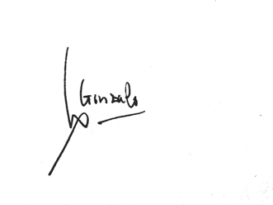
Prof. Dr. Gonzalo Guillén-Gosálbez on behalf of all the co-authors.

